GEOG 577 Lab 1

Fire Fuel Conditions Ahead of the Palisades Fire

**Due Jan 24**

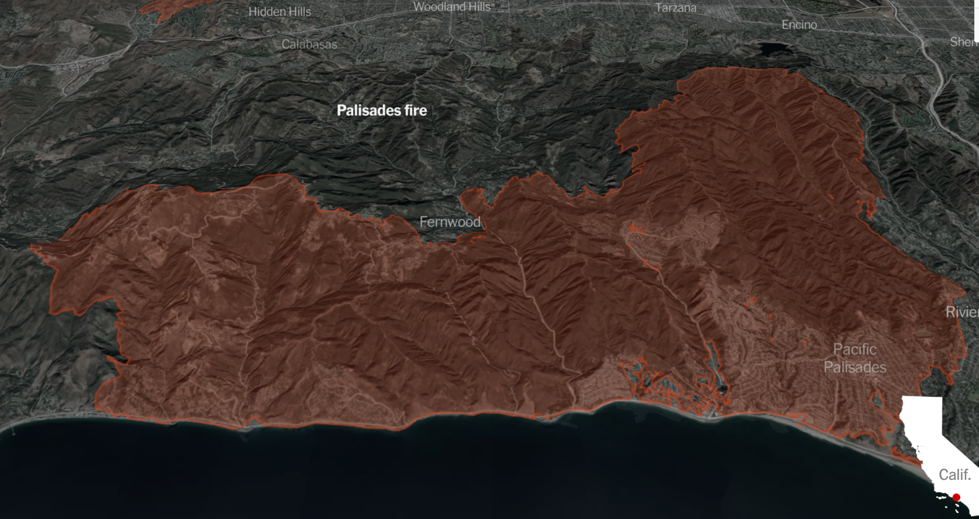

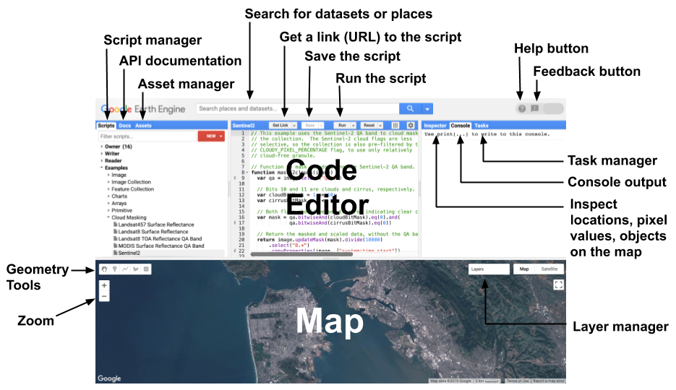

1. Create a *geometry* from Agoura Hills (NW corner) to Bell Gardens (SE corner). To do this you can use “Geometry Imports” and the rectangle selection tool under “Geometry Tools” found in the Map Panel. You can find the location of these two parts of LA by searching for them in the search panel.

2. Import SRTM Digital Elevation Data. You can find and import this data by searching for it in the search bar and importing it. Crop this data to your geometry.

3. Import Sentinal 2 MSI Level 1C data. You can find and import this data by searching for it in the search bar and importing it. After steps 1-3 you should have three items in the “Imports” section (the top section) of your Code Panel.

4. Filter the Sentinal data to two separate date ranges: 06/01/2024 - 06/30/2024 and 12/01/2024 - 12/31/2024. You may want to set up steps 4-8 in separate chunks of code for the two separate date ranges.

5. Filter your data to include less than 5% cloud cover.

6. Mosaic the resulting Sentinel data and crop it to your geometry for both date ranges.

7. Mask out the water.

8. Calculate NDVI for both dates.

9. Calculate the difference in NDVI between the two (Date 1 - Date 2).

10. Display and create (and import) visualizations for the difference image and the DEM data. Before you display the data, set the map display to center on your geometry, and set the scale to 10 or 11.

11. Interpret your results. Specifically: a) What do the different values of your difference image represent? b) Is there a better way (compared to difference in NDVI) to assess fuel conditions from remote sensing data? c) Are these two dates the best dates to use for this analysis? d) What notable patterns do you observe in your difference image, and how might they be explained? e) Summarize the difference in spatial resolution between the SRTM data and the Sentinel Data.

12. When you are done, upload the link to your GEE code to the Assignment Page in Canvas.